Student Name
Mathematics Stage 4
Data Visualisation

Book 2 |  | Version: 251019  Report mistakes & suggest improvements:  https://MrDingMaths.com

Contents
Overview 2
Misleading Graphs 3
Graphing using Spreadsheets 10

Overview

Syllabus Content
MA4-DAT-C-01 classifies and displays data using a variety of graphical representations
Interpret data in graphical representations
- Identify and interpret data displayed on graphs
- Identify features of graphical representations to draw conclusions
- Interpret patterns in graphical representations to make predictions
- Explain why a given graphical representation can lead to a misinterpretation of data

Misleading Graphs
- Misleading graphs have the correct data but give a false impression of the data.
- Misleading features include:
  - The scale on the vertical axis does not start at zero.
  - The scale on the vertical axis is irregular or missing entirely.
  - Not all data is shown – the data is cherry picked.
  - An inappropriate graph is used.
  - And more.
- Graphs can be misleading by mistake, or deliberately used to craft a false narrative.

Example Identify and describe misleading features of graphs.
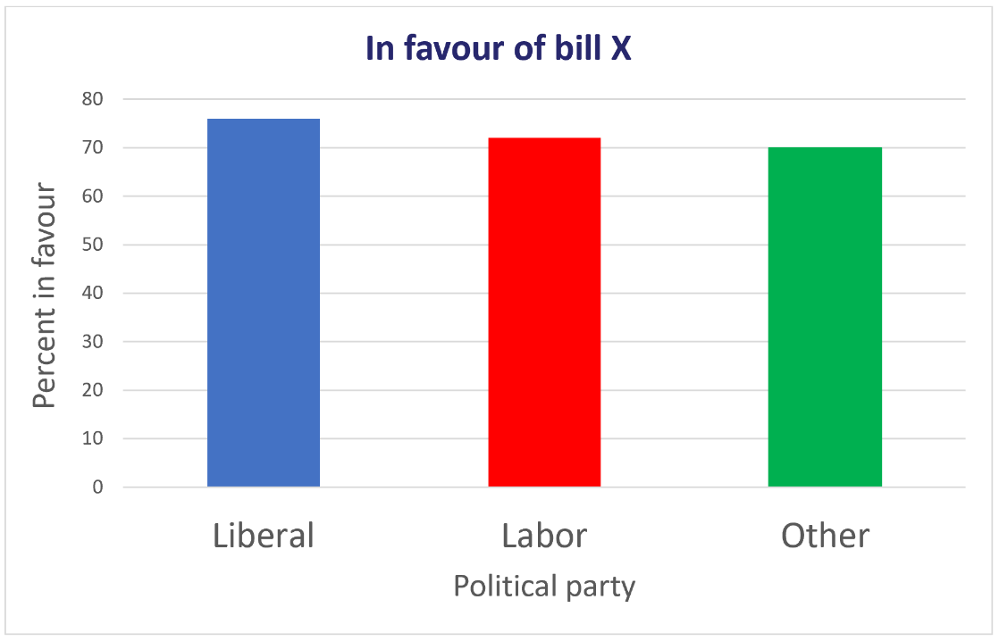
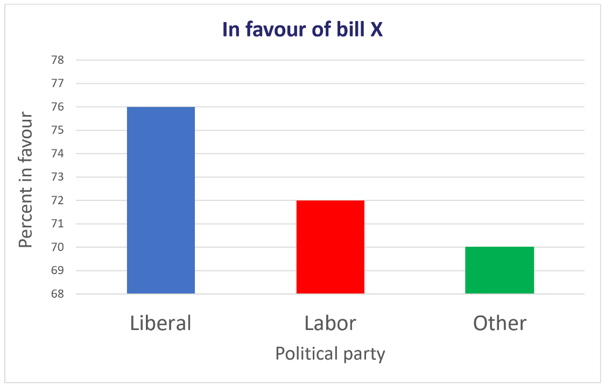
In these examples, the left graph is misleading, the right is the corrected version.
Discuss what makes the left graph misleading.

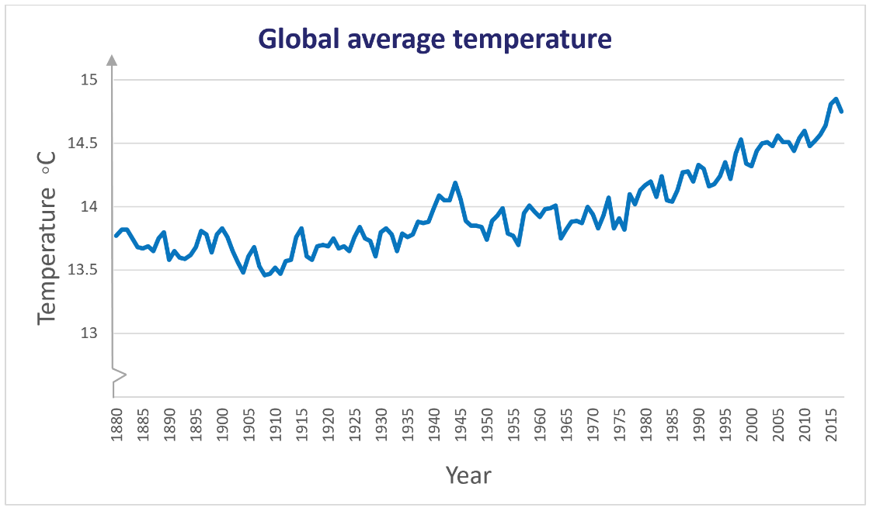
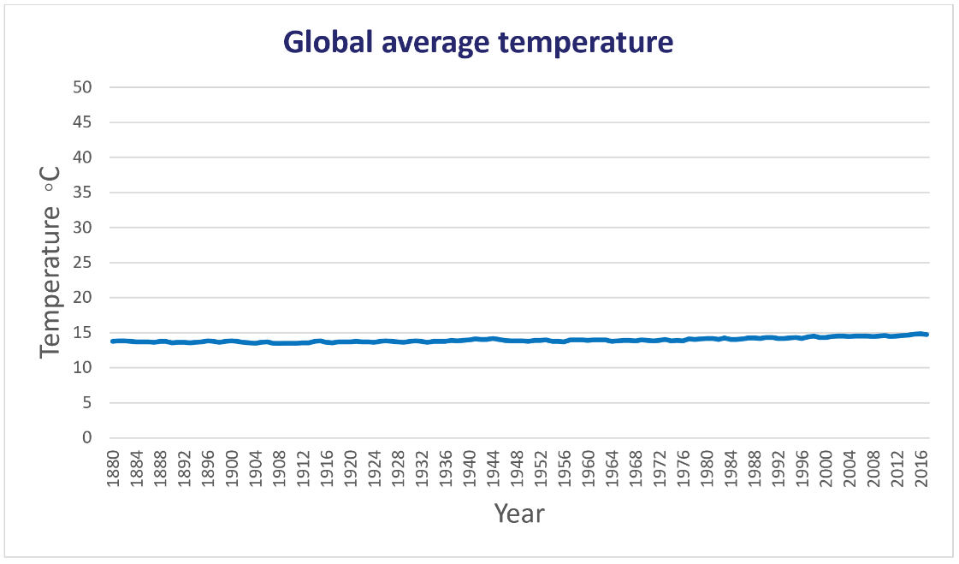

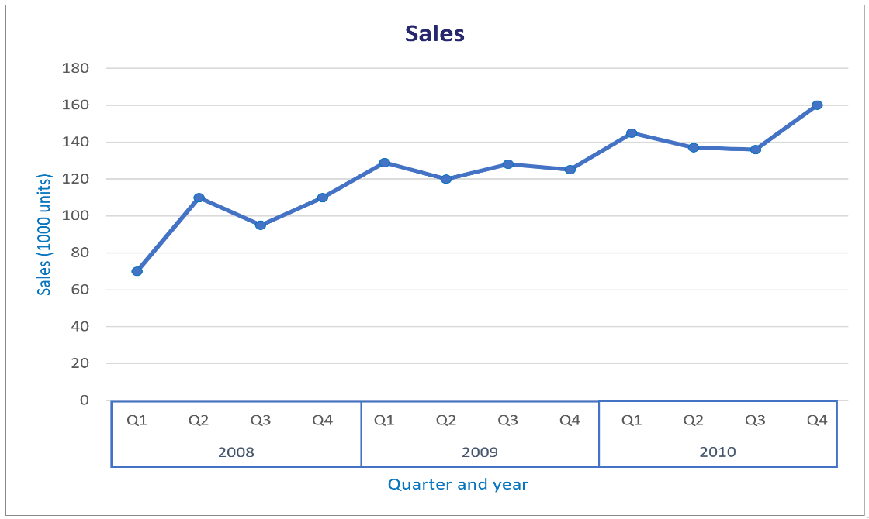
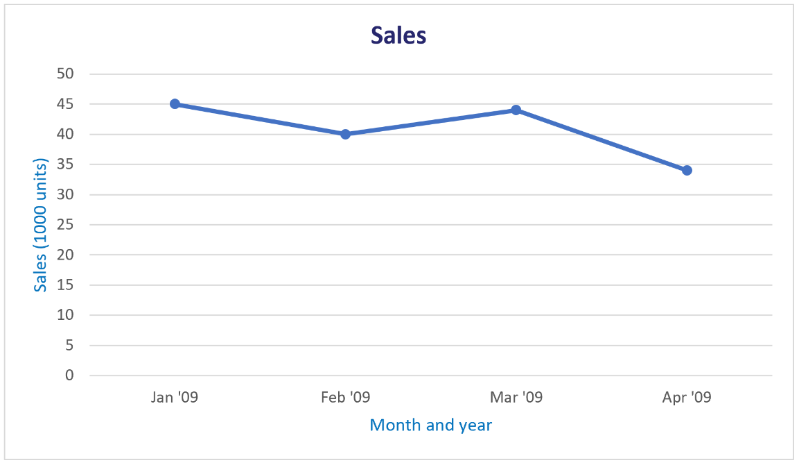

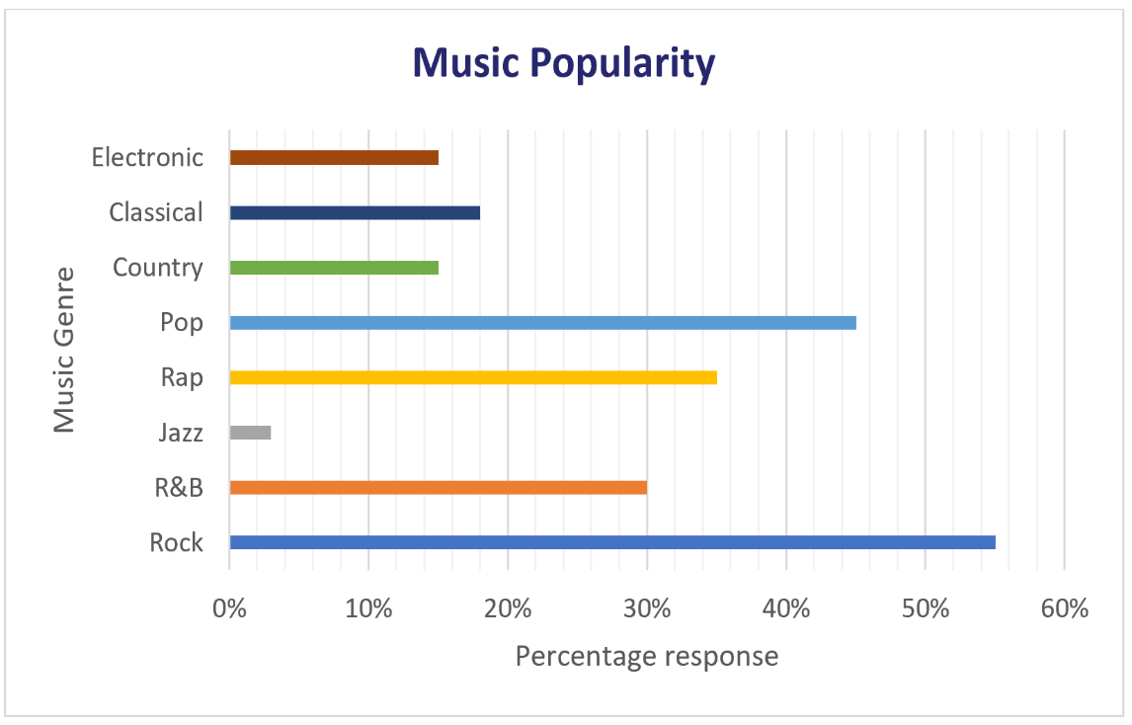
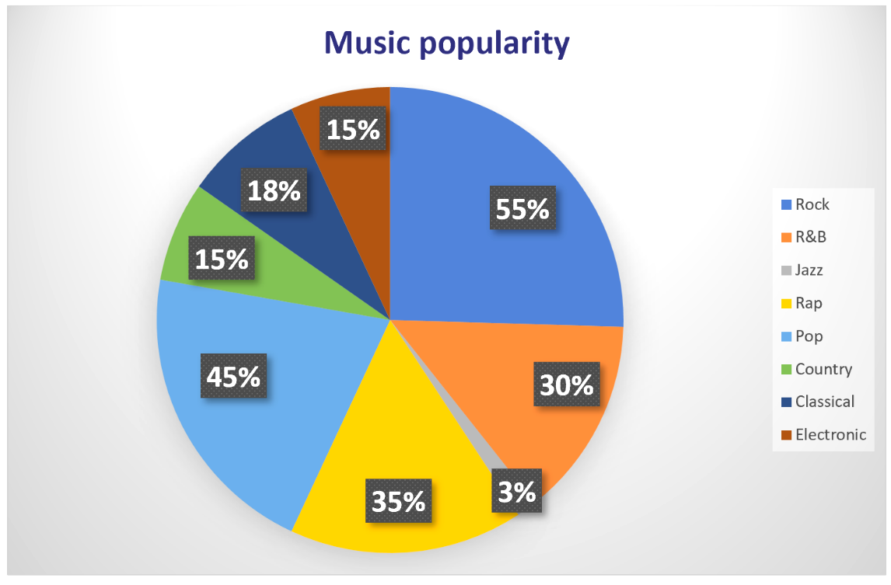

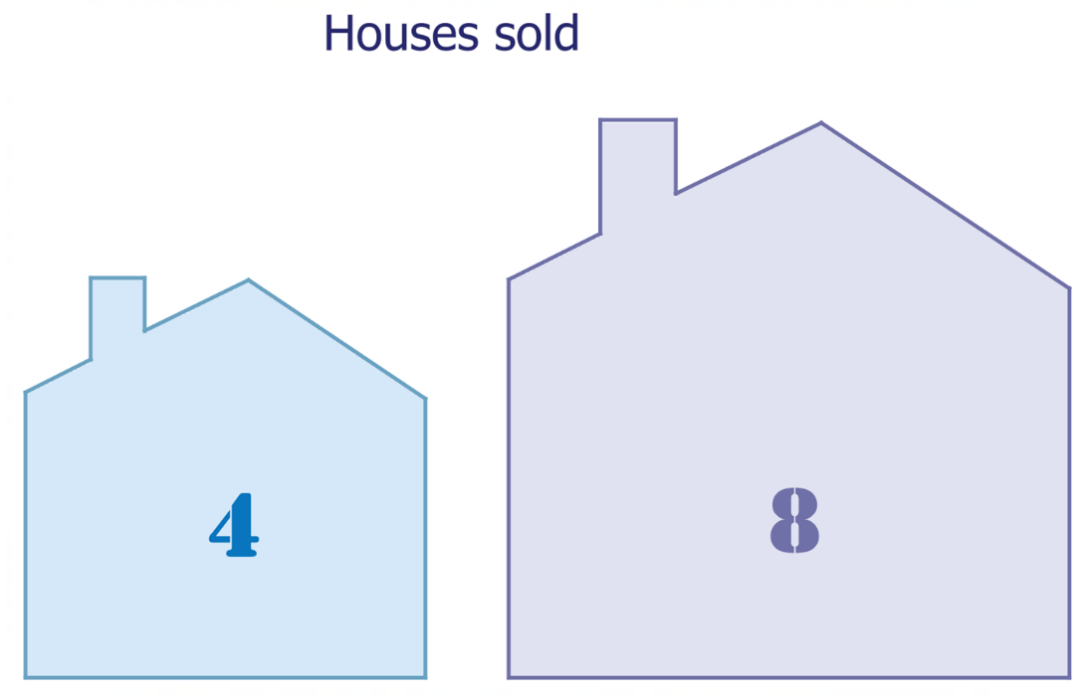
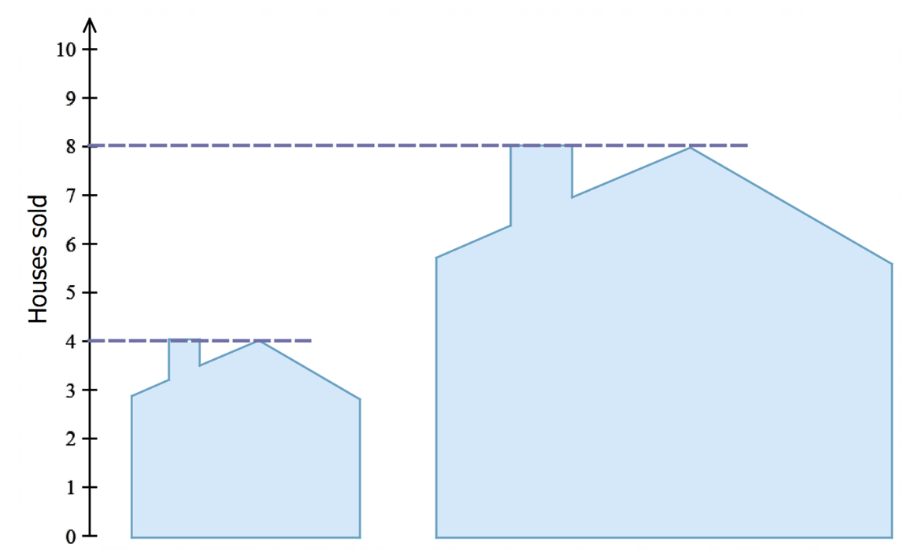

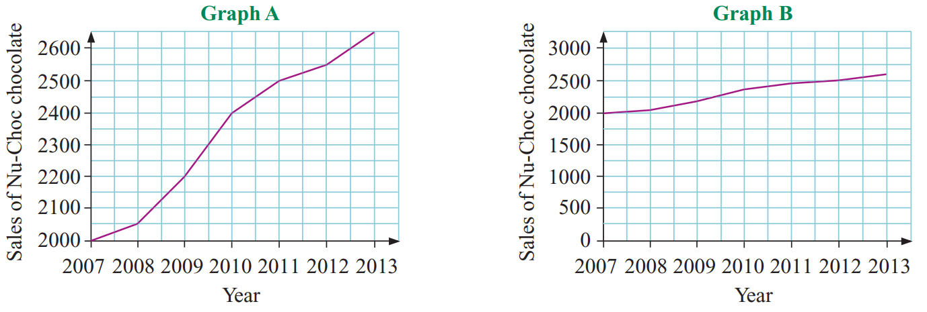
Foundation

  - In graph A, the sales for 2010 appear to be double those of 2009. Is this true?
No
  - What aspect of the graph makes it seem so?
The scale. y-axis doesn’t start at 0.
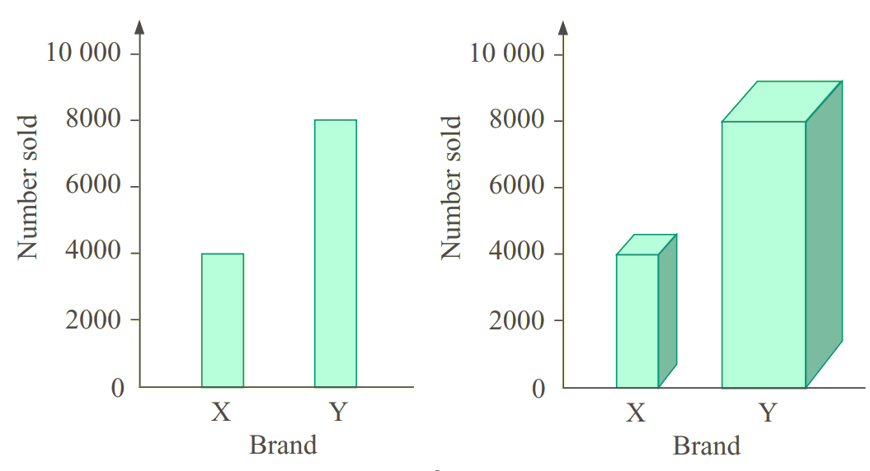
- Look at the two graphs showing sales of two brands of TVs.

Which graph is misleading, and why?

the 3D graph as you can’t tell for sure the height of the column. The width also changes, making the difference look bigger.
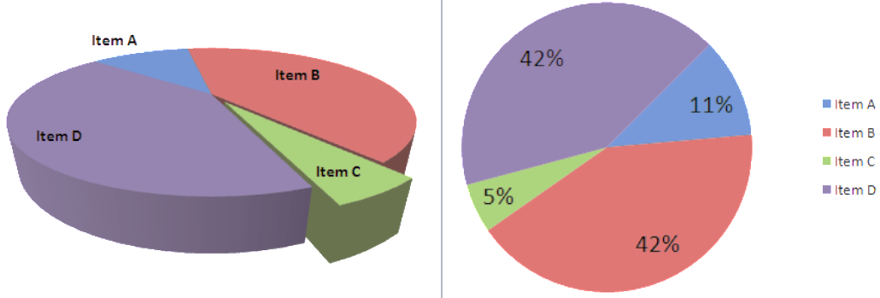
- The two sector graphs show the same information.
Explain why 3D sector graphs are not appropriate (Hint, look at Item C and Item A).

From the perspective of the left graph, the sector that’s far away looks much smaller than it is.

- Describe the misleading or poor features of these graphs.
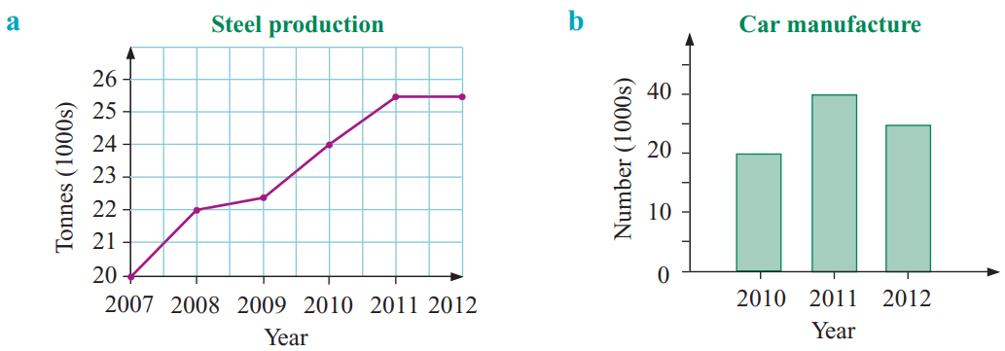  y-axis doesn’t start at 0 | y-axis not increasing in consistent steps
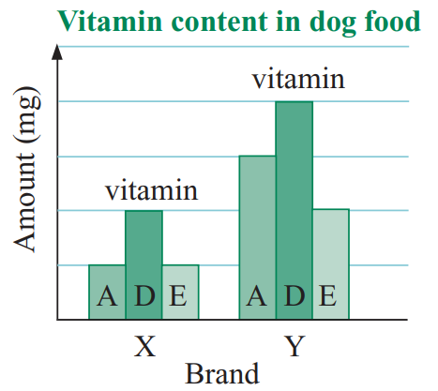  No y-axis scale | 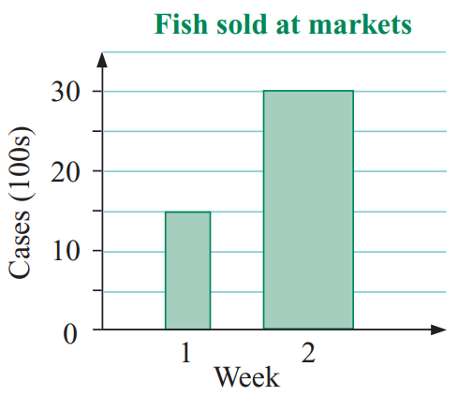  Bars are different wifths
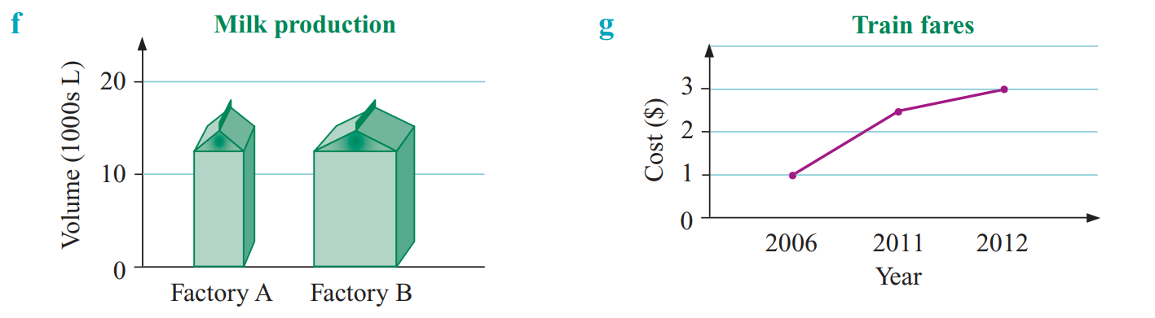  Bars different widths.  3D graph, can’t tell what the actual height is | Year not increasing by a constant amount.
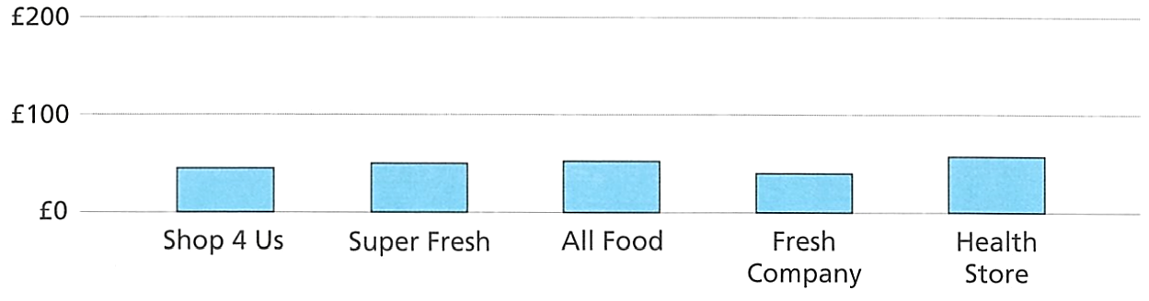
- The price of the same basket of groceries was compared at 5 supermarkets.

  - Explain why the chart is misleading.

The scale is not appropriate. Hard to see the differences.
  - Describe how the chart could be improved

Make y-axis go to 100 instead of 200

Development
- The average score of 5 classes on a maths test was graphed.
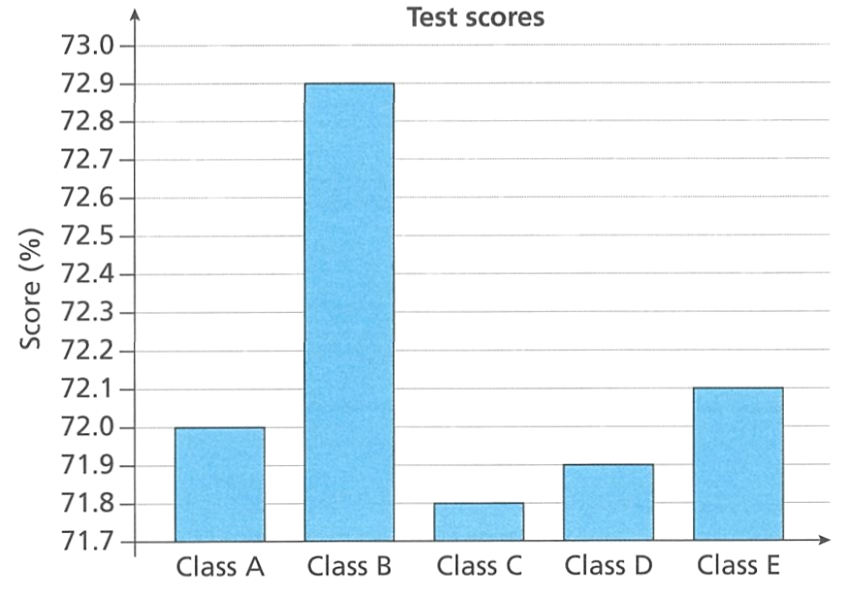
  - Faith says, "Class B's average score was significantly higher than any other class." Explain why Faith thinks this.

The column is much higher than the others.
  - Explain why this chart might be misleading.

The differences are actually very small
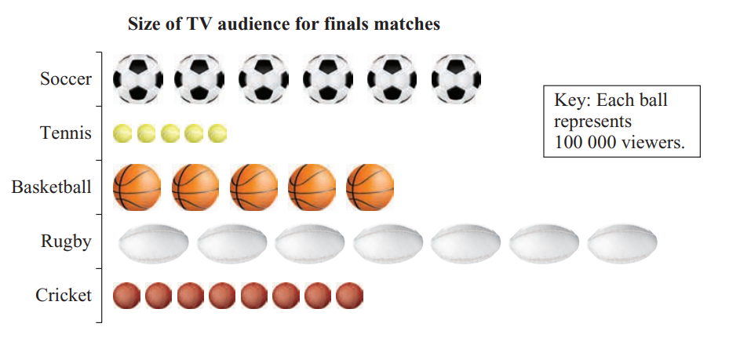
- Explain what is misleading about this pictogram.

The balls are different widths, you might think rugby is more popular when its cricket that’s most popular.
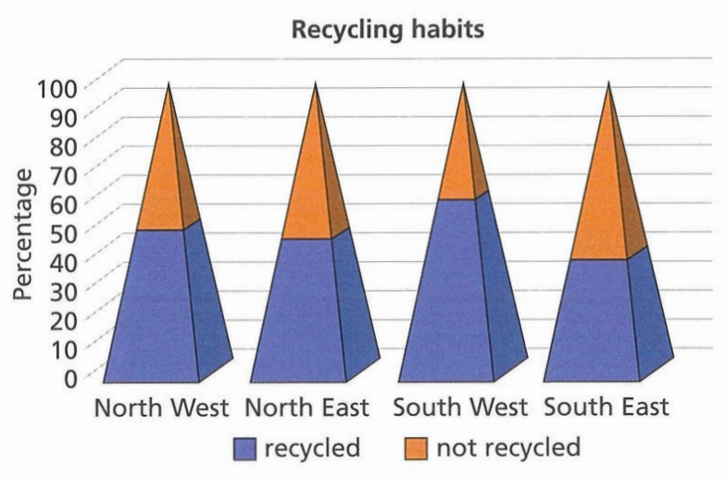
- The chart shows the recycling habits of four regions.
Explain why the graph is misleading.

The pyramids mean the proportion recycled look larger
and the proportion not recycled look smaller
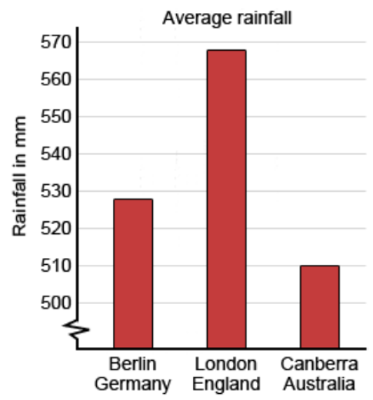
- This graph shows the average rainfall in three capital cities.
Shelly says: “London’s rainfall is around twice that of Berlin, and four times that of Canberra”
Explain why she is incorrect.

London is only 40 mm more than Berlin, not double.
London has around 7.6% more than Berlin

Mastery
- A poll before an election asked “who would you vote for” and allowed multiple selections. Explain why this sector graph is incorrect.
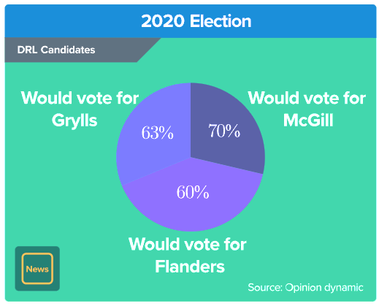

The percentages don’t sum to 100
- From the data, what can we conclude about home prices in the US? Select all that apply.
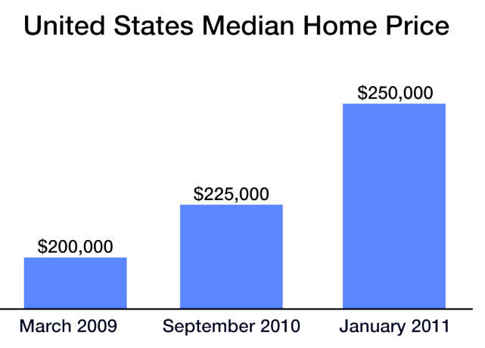
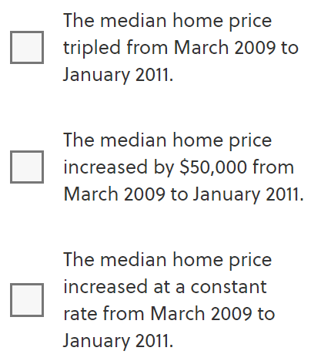

Explain why each option is correct/incorrect.
Option 1:

Median home price increased by 50 000 from 200 000, which is not tripling
Option 2:

This is correct
Option 3:

The rate of increase is not constant as the dates are not equally spaced.
- 2013 HSC Standard 2 Band 4
A survey was conducted where people were asked which of two brands of smartphones they preferred. The results were:
48% preferred Brand X
52% preferred Brand Y
A graph displaying the data is to be included in a magazine article. The editor of the magazine wishes to ensure that the graph is not misleading in any way.
Which graph should the editor choose to include in the article?
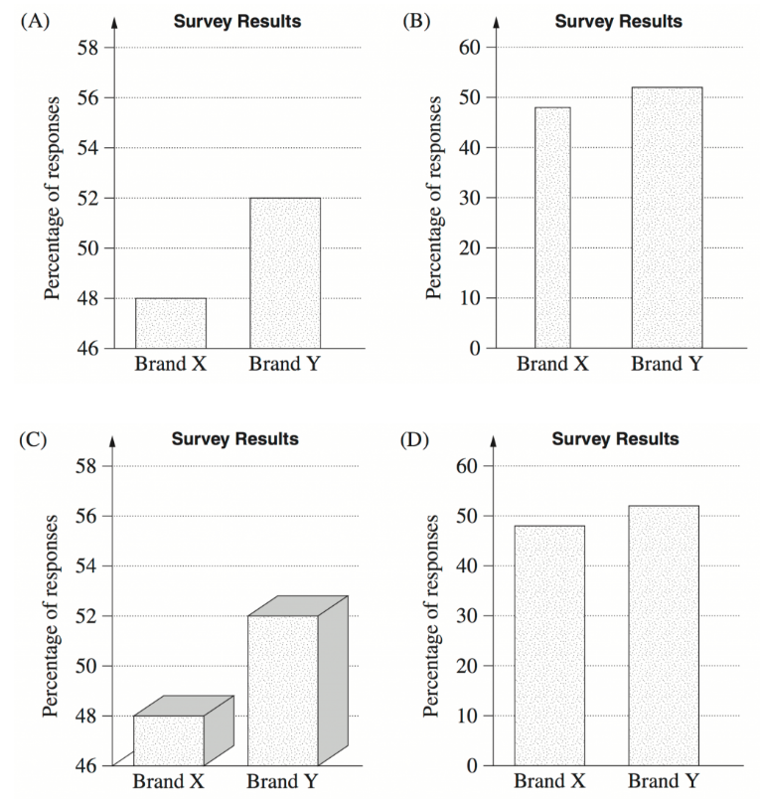

D
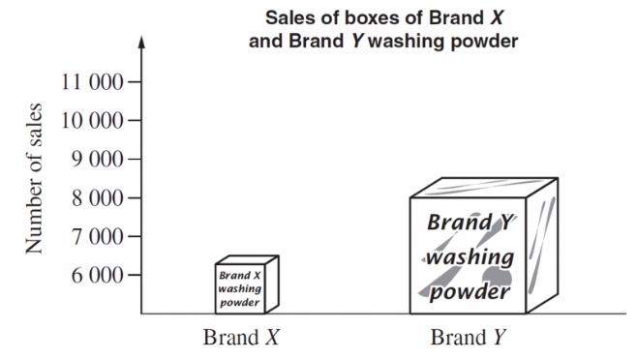
- 2006 HSC Standard 2 Band 4
List two ways in which this graph is misleading.

3D graphs make it hard to tell the actual height of the bar.
The different widths make the differences look larger.
The y-axis doesn’t start at 0.
- 2022 HSC Standard 1
After collecting data, Kim drew the following graph to summarise the opinions
related to the price of the food. What TWO features of the graph make it misleading?
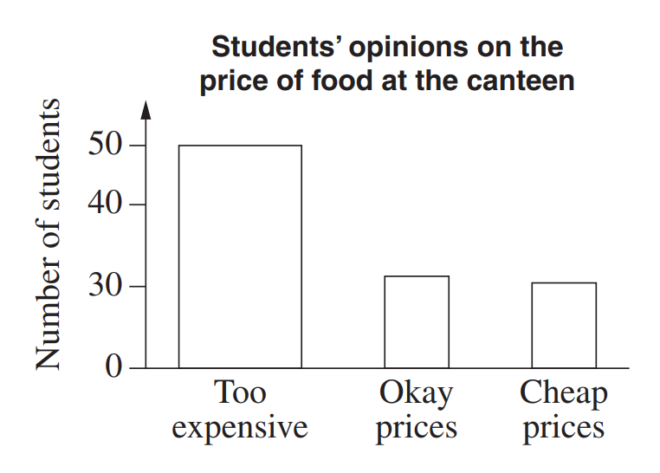

The widths of the bars are different
The y axis scale is inconsistent
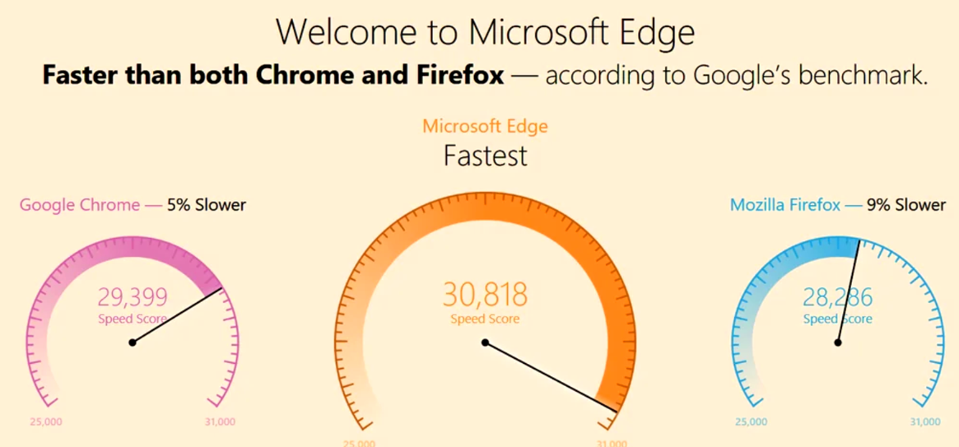
- Explain why these graphs are misleading.

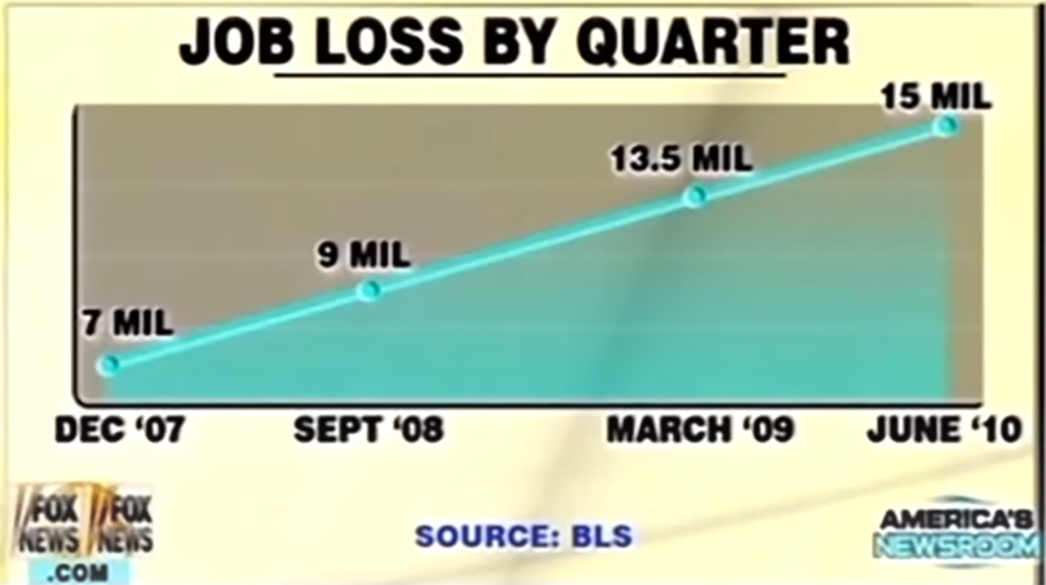
No scale on the speedometers. Differences appear greater than they are.

Dates are not consistent.
Differences look consistent when they’re not
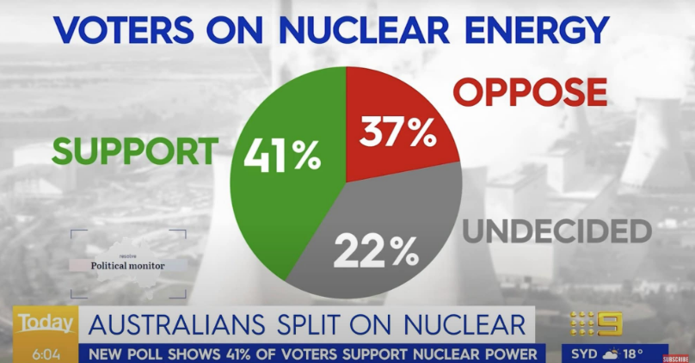

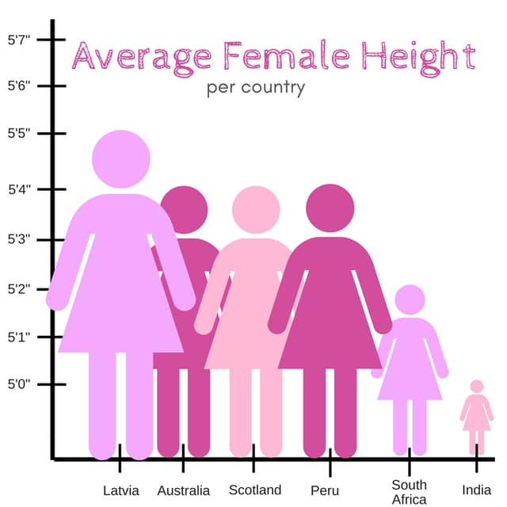
Percentages sum to more than 100%

y-axis doesn’t start at 0.
Both the width and the height are changing, making differences look larger.

